**CHAPTER 1**

**INTRODUCTION**

This chapter gives an overview about the objective of the project and the outline of the report.

**1.1 OBJECTIVE AND SCHEME OF PROJECT**

Millions of people are injured annually in vehicle accidents. Most of the traffic accidents are the result of carelessness, ignorance of the rules like overload in taxies. Proposes and designs a best path selection algorithm, which can solve the problem of path planning for intelligent driving vehicles in the case of restricted driving, traffic congestions and accidents .Huge and complex transportation network environment poses even greater challenges for smart driving technology. In order to ensure that obstacles are avoided in the path selection of intelligently driven vehicles, current optimal path algorithms may miss the best choice due to overcorrection. With the rapid development of artificial intelligence technology and automobile industry, frequent traffic congestion and accidents, residents' travel efficiency and safety issues have received more and more attention. In this context, the idea of optimal path driving traffic system came into being. Vehicle drivers take action in the event of an emergency, but intelligently driven vehicles can only learn and try to avoid the danger of situation like traffic accident, jam and temporary restrictions, etc. in the process of continuous optimization of the path plan, therefore we propose this method to solve best path planning of intelligent driving vehicle.

The path planning of intelligent vehicles is based on the driving tasks and real-time changing environment given by intelligent decision-making to provide the driving area and driving guidance process for intelligent vehicles and this process is based on the controller interacting with the environment to get feedback and use intelligent determination technology to plan the path. It is divided into global path planning and local path planning. Global path planning is a combination of optimization and feedback mechanisms using local information in the case of known map databases to determine feasible regions and optimal paths. Since the path generated by global path planning can only be a rough path, it does not consider the direction, width, curvature, road intersection and roadblock details of the path, and the uncertainty of the local environment and its state during the driving process of the intelligent vehicle, the vehicle may encounter various unpredictable situations during driving, so local path planning must be based on local environmental information. The local path planning is based on the route of the travelable area generated by the global path plan. According to the requirements of each sub-goal of the intelligent vehicle and the local environmental information, the road conditions and accidents sensed by the sensors are quickly and accurately judged, and the optimal controllable driving path of the intelligent vehicle is developed. The A* algorithm is the fastest algorithm for solving the shortest path in state space search in static road network. However, the road network in practical applications is not static, so we need to use other technologies. Reinforcement Learning (RL) is an important branch of Machine Learning (ML). Its goal is to give the machine the wisdom to think and react like a human being . The greatest feature of reinforcement learning is that it can obtain the optimal strategy by maximizing long-term compensation by giving the current state reward.

The traditional identification method of vehicle overload is setting up detection points on highways. In this approach, it is difficult to accurately identify whether it is overloaded. Fixed platform detection station can accurately identify the weight of vehicles, but the installation is complex, difficult to large-scale promotion. With the continuous development of the transportation industry, the problem of vehicle overload becomes more and more serious. Vehicle overload seriously damages road facilities and causes road traffic accidents, which poses a threat to people's life and security. And the vehicle load detection becomes the key to solve this problem. The current vehicle load detection methods include vehicle balance and portable detector. The method of vehicle balance is based on capacitive sensor. When the capacitive sensor detects the vehicle's load, the force of the vehicle on the ground changes the distance between the two plates of the capacitive sensor, resulting in the change of capacitance capacity. The vehicle balance is bulky, expensive, destructive to the road and low efficiency in vehicle load detection. The method of portable detector is based on optical fiber sensor and strain gauge. When the optical fiber sensor detects the vehicle load, the single-mode fiber is used as the sensor arm of Michelson interferometer, and the interference fringe number and the fringe period value are detected to indicate the vehicle load size. Strain gauge detection method is used to detect the deformation of the leaf spring. These detection methods need to change the structure of the vehicle, which poses a threat to the safety of the driver and the vehicle. In view of above disadvantages, the magnetoresistance sensor is small in size, low in cost and strong anti interference ability. And it is not easily affected by the complex environment of vehicles. This paper designs a vehicle load detection system based on magnetoresistance sensor and a permanent magnet, which do not change the structure of the vehicle and can realize real-time detection of vehicle load And the machine learning concepts to predict the optimal path. The structural features of the system are that the two wheels are connected by a full-body axle, and the axle is suspended under the frame by a flexible suspension system. The vehicle load causes the distance change between the axle and the frame. In this paper, the permanent magnet is placed on the axle, and the detection device with magnetoresistance sensor is installed on the frame. And the magnetoresistance sensor is located on the central axis of the permanent magnet. When the load of vehicle changes, the magnetoresistance sensor detects the magnitude change of the magnetic field and obtains the distance between the frame and the axle. Finally, the vehicle load detection can be realized and optimal path can be detected using the new system.

**1.2 REPORT OUTLINE**

This report consist the study about:

* Research to improve the implementation of existing optimal path detection and overload detection in taxies.
* Research to improve the quality and performance of currently available classifying methods.
* How facial recognition method can be implemented on the passenger overload detection in taxies.

**CHAPTER 2**

**LITERATURE SURVEY**

This chapter focuses on the surveys conducted on different journals as a part of literature survey:

**2.1 A NEW ALGORITHM OF THE BEST PATH SELECTION BASED ON**

**MACHINE LEARNING**

With the development of artificial intelligence technology and the concept of intelligent transportation system, the technology of intelligent driving vehicles has become a hot spot of research. The huge and complex transportation network environment poses even greater challenges for smart driving technology. In order to ensure that obstacles are avoided in the path selection of intelligently driven vehicles, current optimal path algorithms may miss the best choice due to overcorrection. With the rapid development of artificial intelligence technology and automobile industry, frequent traffic congestion and accidents, residents' travel efficiency and safety issues have received more and more attention. In this context, the idea of intelligent driving traffic system came into being.

Path selection is an important aspect for intelligent driving vehicle. This part will design a length-first best path algorithm based on reinforcement learning strategy, referred to as OPABRL (Optimized Path Algorithm Based on Reinforcement Learning). The shortest path algorithm can solve the first part of the problem. For the second part, we consider rasterizing the road network, and determine whether it is an obstacle based on whether the grid is safe or not. Here, the obstacle mainly contains three cases, including traffic restrictions, accidents and congestions. The restrictions mainly refer to three conditions: height limit, width limit and weight limit; traffic accidents are divided into three levels: mild, moderate and heavy congestion; traffic congestion is divided into slight congestion, slow and heavy congestion.

Reinforcement Learning Strategy Based on Prior Knowledge:

Definition 1:

We define the cost equivalent of misidentification as virtual time .The error equivalent time here includes the cost equivalent time due to the wrong judgment, and the cost equivalent time of turnings and crossings . When the system detects an unsafe grid with obstacle, the probability of wrong judgment for a non-obstacle grid is almost zero due to the prior knowledge, here we ignore this situation.

Theorem 1:

The smaller the virtual equivalence ratio the smaller the cost of misidentification, and the better the performance of the algorithm.

Theorem 2:

When cost is used as the reference standard parameter, the problem is simplified to the solution of the minimum .At this time, the greater the total cost time, the smaller the reward, the slower the update of the Q value, and the slower convergence of the reinforcement learning algorithm.

Definition 2 :

The Q-value function is used to obtain the optimal strategy under unknown conditions, and the Q-value function under the optimal strategy is called the best Q-value function, which can be understood as the fixed point of a certain operator GM, and it meets.

Establishment of Vehicle Driving Network:

Topology In order to realize the auto-positioning of intelligent vehicles and the path planning in the whole region, it is necessary to use the sensors carried by them to detect the environment data of the outside world and use the data to model the external environment. The basic idea of grid map is to divide the working environment of intelligent vehicles into identical grids and each grid corresponds to a specific small area in the environment. When the sensor detects that the environment changes, the grid map will maintain timely. We use the grid method to construct the environment map, when using this method to model the environment, the more grids are divided, the smaller the map and the higher the accuracy of the map for the same working environment. This process can be divided into two steps:

Boundary learning process:

The process of boundary learning means that the intelligent driving vehicle starts searching driving area in a specific direction along the boundary of the area or the boundary of the obstacle next to the boundary, and learns the contour of the entire driving environment and distribution of obstacles by the boundary in the process .The black grids represent obstacles and white part represents the safe area.

Environment map generation:

The environment map is in the form of rectangular grid. By dividing the entire environment area into grids, the actual environment is mapped to grids to realize discretization of the driving environment. If the size of the vehicle is d and the grid size is the same as the size of the vehicle, then the number of grids in this map is: 侠. The grid is represented by G.th is used to describe the data of the area represented by the grid, and x, y represent the horizontal and vertical coordinates of the grid in the entire area;th indicates whether the grid contains an obstacle. Whenth is 1, it means that the grid is an unsafe grid (that is, the grid contains obstacles) and the grid is output black. Whenth is 0, it means the grid is a safe grid (that is, this grid does not contain obstacles) and the grid is output white.

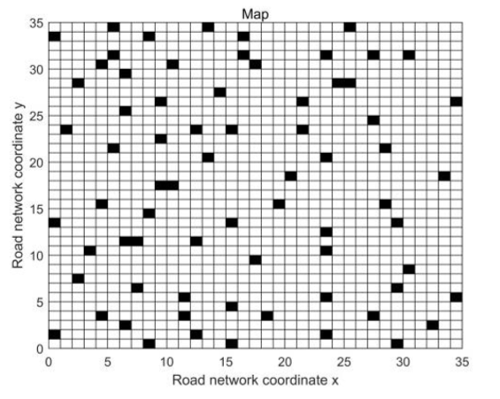

Fig 2.1.1 Grid map

**2.2 VEHICLE OVERLOAD DETECTION SYSTEM BASED MAGNETO**

**RESISTANCE SENSOR**

The current vehicle load detection methods include vehicle balance and portable detector. The method of vehicle balance is based on capacitive sensor. When the capacitive sensor detects the vehicle's load, the force of the vehicle on the ground changes the distance between the two plates of the capacitive sensor, resulting in the change of capacitance capacity. The vehicle balance is bulky, expensive, destructive to the road and low efficiency in vehicle load detection. The method of portable detector is based on optical fiber sensor and strain gauge. When the optical fiber sensor detects the vehicle load, the single-mode fiber is used as the sensor arm of Michelson interferometer, and the interference fringe number and the fringe period value are detected to indicate the vehicle load size. Strain gauge detection method is used to detect the deformation of the leaf spring. These detection methods need to change the structure of the vehicle, which poses a threat to the safety of the driver and the vehicle.

The vehicle load causes the distance change between the axle and the frame. In this paper, the permanent magnet is placed on the axle, and the detection device with magneto resistance sensor is installed on the frame. And the magnetoresistance sensor is located on the central axis of the permanent magnet. When the vehicle load changes, the magneto resistance sensor detects the magnitude change of the magnetic field and obtains the distance between the frame and the axle.Finally, the vehicle load detection can be realized. The vehicle load detection device installation diagram is shown in

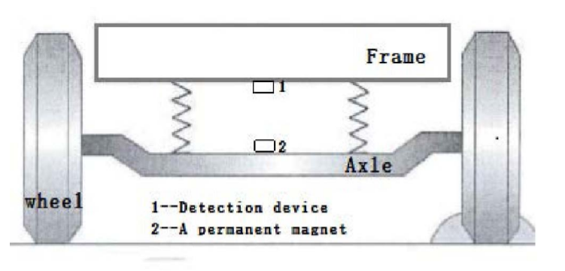

Fig 2.2.1 Detection device installation diagram.

The vehicle overload detection system mainly consists of load detection device, Beidou terminal, driver's handheld device and so on. The vehicle overload detection system is shown in Fig. 2. The load detection device is based on the magneto resistance sensor. When the vehicle loads, the distance between the axle and the frame changes, which is the distance between the magneto resistance sensor and the permanent magnet. The load detection device uses the magneto resistance sensor to detect magnitude change of permanent magnet. After the processing of MSP430, the detection device sends the vehicle load information to the driver's handheld device and Beidou terminal. The beidou terminal records the load information in real time and sends the load information to the remote monitoring center. The handheld device is convenient for the driver to check the load. When the vehicle is overloaded, the handheld device sends out the alarm message.

The hardware of the system is mainly composed of magnetoresistance sensor, amplifier circuit module, AD converter module, Single chip microcomputer, communication module, power module, etc. The hardware structure is shown in fig

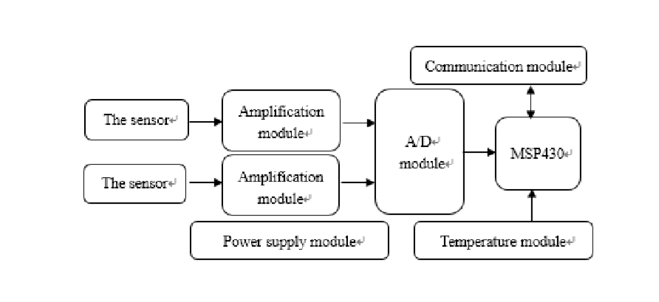

Fig 2.2.2 Detection device installation diagram

The principle of magneto resistance sensor is based on the anisotropic characteristics of magneto resistance materials. The basic device of the sensor is the wheat-stone bridge, which converts the magnetic field magnitude variation into the form output of the differential voltage, and the output voltage is proportional to the magnitude of the magnetic field in a certain range. In order to solve the problem of vehicle overload, vehicle overload detection system based on magnetoresistance sensor and permanent magnet is designed. The system can obtain the load information by measuring the distance between the axle and the frame. Through experiments, the system can detect the load of vehicles accurately and in real time. When the vehicle is overloaded. The system can send vehicle overload alarm information. In addition, the system communicates with the beidou terminal and sends the vehicle load information to the remote monitoring center. Compared with existing methods of vehicle load detection, this method has many advantages. For example, this method has strong anti-interference ability, high accuracy and not easy to be affected by the complex environment of the vehicle. the system costs less and does not change the vehicle structure. There is no threat to the safety of drivers and vehicles. And the system has certain engineering significance.

**2.3 CONTINUOUS PATH DETECTION METHOD OF INTELLIGENT**

**TRACK-SEARCHING VEHICLE BASED ON PHOTOELECTRIC**

**SENSOR**

The detection distance and accuracy of the path are two key factors of photoelectric intelligent track-searching vehicles. Firstly, through the analysis of operating principles of photoelectric sensors, this article designs a circuit for photoelectric sensors. This circuit could make photoelectric sensors work in impulse state, enlarging their detection distance of the path. Secondly, traditional path detection algorithms could not get enough information of path conditions, which is discrete and not continuous. According to the study of characteristics of photoelectric sensor, the special feature curve of photoelectric sensor is found out. Based on this feature curve, this article puts forward a continuous detection algorithm of intelligent vehicles. Experimental result demonstrates that this algorithm not only improves intelligent vehicle’s speed but also promotes its systemic stability. Therefore, the continuous path detection method proposed by this paper has high accuracy, large detection range and high practicability.

Proposed Methodology:

In the process of collecting path information, the photoelectric sensor is greatly influenced by external lights and the colour of the path. Since the wavelength of infrared light is longer than visible lights, and its scattering degree is smaller, the infrared sensor receives less interference of external light source. As a result, the path information obtained by infrared sensors more factually reflects the path conditions.

The reflective infrared sensor includes a solid-state light-emitting diode (LED) for emitting infrared light and a solid-state photodiode (or phototransistor) as receiver, which are tied together. Usually there is no light in the receiver. The sensor works only when the infrared ray from LED encounters reflective objects and then the photodiode receives the reflective infrared ray. The detection circuit of infrared photoelectric sensor is shown in Fig.1.The working principle: objects of different colours have diverse degrees of infrared ray absorption, resulting in the remarkable distinctions in reflection coefficient of infrared ray. Path of intelligent vehicles contains two colours: black and white, white as background and black as the central guiding line. As for the two-colour path, the receiver of sensor will receive different reflected lights and it will produce different currents according to the degree of reflected lights, with a distinct correspondence output voltage of the PAD side.

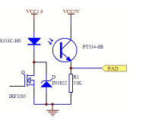

Fig 2.3.1 Detection circuit of IR photoelectric sensor

Therefore, according to voltage in PAD side of sensor’s receiver, the path color can be identified, and the moving direction of intelligent vehicles can be determined through the synthesis and analysis of multiple sensors’ receivers. Based on the look-forwarding requirements of path information for intelligent vehicles, it is necessary to increase the detected distance of infrared photoelectric sensors. The tests show that the detected distance is propositional to the emitting power of the emitting diode. In order to increase the detected distance of the infrared photoelectric sensor, the emission distance of infrared light must be enlarged accordingly.

THE FEATURE OF PHOTOELECTRIC SENSOR :

Analysis of Sensor’s Feature :

Infrared photoelectric sensor doesn’t simply output high or low voltage (high voltage when sensor is above the white area and low voltage above the black line), for it has its own voltage-offset feature curve. There is quantitative relationship between the output voltage of sensor’s receiver and its horizontal distance away from the black path guiding line: the nearer from the black guiding line, the lower voltage, and vice versa (the specific correlation is related to the type of infrared photoelectric sensor and its detected distance). The curve of infrared photoelectric sensor, the offset distance from the sensor to the black guiding line can be determined by the voltage value of sensor’s receiver.

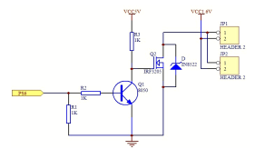

Fig 2.3.2 Impulse trigger circuit of LED

Hence, as long as mastering the voltage - offset feature curve of infrared photoelectric sensor, the offset distance from the sensor to the black guiding line can be determined by the voltage value of sensor’s receiver. The precise distance from the central part of intelligent vehicle to the black path guiding line can be identified by two factors: the offset distance of multiple sensors and the relative position of each sensor. In this way, the continuously distributed path information can be obtained.

Determination of Sensor’s Feature :

The determination of infrared photoelectric sensor’s feature curve is the basis to achieve the recognition of continuous path for intelligent vehicles. Its accuracy has great impact on the precision of continuous path recognition. A special circuit board with adjustable terrain clearance and elevation is made to determine the feature curve of sensors.

The Arrangement of Sensors:

Sensors can be arranged in the vertical pattern (—) or the splayed pattern (∕ ∖). Vertical pattern is the most commonly used pattern for sensor arrangement in which all the sensors are in one straight line to ensure the vertical consistency while keeping the control strategies in the horizontal direction. Splayed pattern adds the vertical features for certain look-forwarding. Since the feature curve of photoelectric sensor is mainly determined in the horizontal direction, the vertical pattern of arrangement is applied.

The Distribution of Sensors:

The distribution spacing of infrared photoelectric sensor is related to the width of path guiding line and the terrain distance of sensors. Generally it requires the path guiding line under sensor to cause response from one or two sensors as standard.

The Relative Height to the Path and the Angle of Sensors:

These two parameters determine the detected range of the path. The interference is relatively reduced because of the use of infrared photoelectric sensors in the design process. The best terrain clearance and elevation can be set down according to the several experiments before the feature determination for the satisfaction of great look-forwarding.

The algorithm of continuous path detection :

The algorithm of continuous path recognition contains three parts: the determination of photoelectric sensors’ feature in debugging phase, the calibration of path information for intelligent vehicles before running, and path recognition within decision-control period in the process of running.

The Establishment of Initialized Data for Each Infrared Photoelectric Sensor:

According to the arrangement of infrared photoelectric sensors and the distribution distance, the horizontal location of each sensor is determined with respect to the central part of intelligent vehicle, establishing arrays of its relative positions.

X_Point [9] {-100, -75, -50, -25, 0, 25, 50, 75,100}

The Calibration of Path Information for Intelligent Vehicles before Running:

For different lights and track conditions, the maximum and the minimum voltages of infrared photoelectric sensors are not the same, so the maximum and the minimum reference values of each sensor voltage need to be determined by sampling the path information before intelligent vehicle running. This process is called calibration.

**2.4 PASSENGER FLOW MONITORING OF ELEVATOR VIDEO BASED ON COMPUTER VISION**

Passenger flow monitoring plays an important role in elevator intelligent monitoring and elevator operation status analysis. This study gives one of definitions for elevator passenger flow, and proposes a counting method of the passenger flow in elevator based on the fusion of computer vision techniques. This experiment calculates the passenger flow in real-time detection by dividing the task into three parts, which is detecting the door status using the background subtraction method, detecting the current floor with Support Vector Machine (SVM) algorithm and counting passengers by YOLOv3 (You Only Look Once) model. The results show that the proposed method can accurately measure passenger flow even when passengers are heavily obscured. In the era of rapid development of economy and technology, high-rise buildings become more and more popular, which causes a sharp increase of elevators. With the advent of the golden age of artificial intelligence, people pursue more comfort and better security.

Elevators need to meet the demand of intelligence, which means monitoring various of data and analyzing them. One of the significant aspects is video monitoring in elevators. This study proposes a method for detecting passenger flow in elevators and achieve three real-time detection algorithms about the door status detection, the floor detection and passenger detection There are many moving object detection methods for detecting door status. Common methods such as frame difference, background subtraction, optical flow method and so on.

It presented a universal background subtraction algorithm for video sequences This work is supported by National Key R&D Program of motion detection that incorporates several innovative mechanisms, and Han et al used the optical flow method to detect objects and gave a method to reduce the complexity to satisfy the real-time request. Real-time floor detection problems can be considered into Optical Character Recognition (OCR) issues. There are various of methods to solve OCR problems based on the connected domain analysis, sliding window recognitions, machine learning and deep learning fields.Though extensive used in pedestrian detection and get good results, it costs too much time to detect objects and cannot be capable of real-time detection. AdaBoost method, used to detect faces, can also do passenger detections.

2.4.1 FLOW COUNTING METHODS

Definition of flow in elevators:

To make the problem clearer, this study defines the flow units as follows: One passenger rises or falls one floor as a flow unit. The formula for calculating flows are shown below



The variable num means the number of people during the period in an elevator, *floor1* represents the floor when the elevator’s door closed and start moving, *floor2* is the floor when elevator stops and the door opened. For example, if five people go up from ground floor to tenth floor, and the flow of people in this period is 45.

Background subtraction method:

For a stable monitoring scenario such as an elevator, the lighting does not change and the background will hardly change. There is a big advantage in this scenario by using background subtraction method to detect moving object. Background subtraction which extracts the target area using differential operations of different images and aims to detect the status of the door for elevators, is a simple and effective method in this situation.

The background frame is initialized with a picture from camera videos when the door is closed. because of the stable environment in elevator, there is no need to change the background frame frequently. In this study, the background frame updates only when there are no people in the elevator and the door is closed.

SVM method

SVM is a common method of discrimination. In the field of machine learning, it is a supervised learning model and commonly used for pattern recognition, classification, and regression analysis. SVM does well in handwriting digit recognition, such as MNIST datasets. In this study, SVM method is used to do the OCR job, which is mainly for the recognition of current floor from inside display panel of the elevator.

YOLOv3 method

YOLOv3 is a real-time object detection method, whose whole detection pipeline is a single network, which can be optimized end-to-end directly on detection performance.

YOLOv3 is the third version of YOLO, and with the improvement from generation to generation, it becomes the state-of-the-art detection systems in real-time object detection. YOLOv3 method can recognize multiple objects, but it only be used to detect people and count them in this paper.

2.4.2 SYSTEM DESIGN

Detection of door switch:

To get faster detection and avoid interference from passengers, background subtraction method uses the ROI (Region Of Interest), right above area in each frame.The total steps are as follows:

(1) Grayscale processing

Grayscale processing, which is the important step to deal with pictures, aims to change the RGB frames to gray frames.

(2) Subtraction processing Subtraction processing method uses the foreground frame to minus the background frame, and gets the differential frame after this differential operation. The position of door has white area and other areas are almost black. the result is shown in Figure

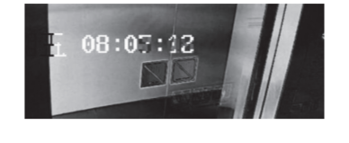

Fig 2.4.1 Frame after differential operation

(3) Binarization processing:

Threshold transformation method is used to convert the differential frame to binary one, which can simplify the subsequent work. The picture is shown in Figure

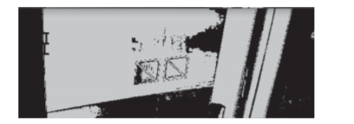

Fig 2.4.2 Binary base

(4) Erosion and dilation processing

After Binarization, it is necessary to filter and smooth the frame. The erosion method is used to eliminate the noisy point and the dilated way is used to extend target and smooth the edge.



Fig 2.4.3 Erosion protection

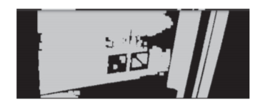

Fig 2.4.4 Dilation processing

(5) Detect the status of the door

It is easy to get the status of the door after performing the above steps: if the ROI is all black, then the door is closed; else if the frame has white area, the door is opened, and the bigger the width of white area is, the wider the door are opened.

Detection of floor

(1) ROI choosing

The position of the display panel relative to the elevator camera is almost unchanged, so a small area in video frames is chosen to simplify the problem and speed up the processing

(2) Sliding window method

Training data of ten digits are from MNIST datasets, and it is necessary to invert the color from black-digit on white-image to white-on-black images, which means the array of images need to swap 0 and 1, since images are binarized. Directions of data of elevators are from many days of videos. And after using data augmentation method, it gets the same amount of data as these digit data. Negative data is also requested. They are chosen from video data of elevator cameras, and the amount of negative data is three times bigger than positive ones.

(3) Test data processing

The processing of input data from videos is similar to the processing of door switch detection. After the subtraction and binarization, input images which SVM model needs are got.

(4) Model training and result

SVM algorithm is used to train and predict, and it achieves 97% accuracy of test data from videos after training steps. And by simply using voting method, which means to predict multiple times in different period and vote.

Detection of passengers

1) Non-Maximum Suppression (NMS)

YOLOv3 system predicts many detection boxes after classifications of the classifier, and many of them intersect with other boxes over a large area. The goal of NMS is to remove redundant detection frames and keep the best one.

Every candidate box has a confidence score, which reflect how confident the model is that the box contains an object. The second threshold is about the confidence score. This experiment set 0.2 as this threshold. The box will be abandoned if the confidence score is below 0.2. The comparison between the result using the NMS method and no using one is as follows. The detection with NMS only left one box for each object, while the other one has multiple detection boxes.

2) Multiscale prediction

Using multiple scales can strengthen the accuracy for small target detection. The main idea are as follows. The algorithm predicts boxes at 3 different scales, the first scale adds some convolutional layers after the base network and output the box information. The second scale samples from the penultimate convolutional layer in scale 1 (x2), then adds the feature map of the last 16x16 size and outputs the box information again after multiple convolutions. The final scale is similar to the second scale by using the feature map of 32x32 size and the antepenult layer. the Multiscale method is used to predict people and count them. It can help improve accuracy for detecting passengers whose body are severely obstructed or those one that only show his head.

This study takes advantages of the computer vision and do all the jobs of door switch detection, floor detection and passenger detection by only using the camera sensor, and achieves the goal of passenger flow statistics in real in time detection.In this experiment, passenger flows are counted by detecting door status, floor information and passengers using background subtraction, SVM algorithm and YOLOv3 method, respectively. The result shows that the flow of passengers in the elevator can be calculated accurately in the video even when passengers are heavily obscured.

purpose, travel time, and destination choice, etc. For example, Scott and He (2012) used the trip destination and travel time as constraint variables to predict the trip path, making the prediction result more accurate. Habib (2018) constructed a comprehensive utility- based model system to simulate workers’ daily activity- travel behavior .Paul(2014) conducted a comprehensive study on demography, sociology, anthropology, economics and transportation engineering area to better understand the dynamics of evolution overtime and their impacts intravel behavior. Bowman and Bradley (2005) constructed an activity-based travel demand prediction system in consideration of purpose, time of day and location.

Data:

The study area of this paper is the urban area of Changchun, which is the provincial capital of Jilin province, with a population of 7.489 million in 2017. The built-up area of central city in Changchun is 506.33 square kilometers. According to the Trafﬁc Analysis Report of Major Cities in China in 2017 (Auto navi Software Co.), the morning peak period and the evening peak period in Changchun are 7:00-9:00 and 17:00-19:00 respectively. Congestion delay indices of peak and off-peak period are 1.90 and 1.48 respectively. In order to obtain the multi-day travel records, this paper conducted a RP and SP travel survey in 2017.

Rp survey data for path selection :

According to the residents’ travel survey data collected in Changchun in 2015, commute trips occupy about 66.77% of all trips on weekdays, while shopping trips account for 65.27% of all trips on weekends. So the commute trips on weekdays and shopping trips on weekends are deﬁned as high-frequency trips, of which the path selection behavior will be examined in this paper.

Sp survey data for link selection :

A survey was designed to collect travelers’ link selection data, personal socioeconomic information and travel information. The respondents are required to choose links under different trafﬁc conditions for the two provided optional paths. In this paper we deﬁne that a path consists of multiple optional links as illustrated in fig. The nodes denote the intersections connecting the optional links, of which the number may be less than that of actual road intersections.

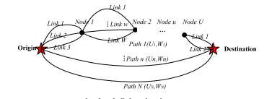

Fig 2.4.1 Path link and node

Establishing a hybrid path prediction model:

To understand drivers’ path selection behaviors, we divide the process into two parts, i.e., the pre-trip path selection and the during-trip link adjustment. Thus, the hybrid path prediction in this paper is distinguished between the pre-trip path prediction considering habits, and during-trip link prediction considering both habits and real-time trafﬁc conditions.

In this paper, we propose a hybrid prediction model for drivers’ path selection, which composes of the pre-trip path prediction model and the during-trip link prediction model. The results indicate that the path selection behavior revealed by the hybrid model align with the behavior from the survey data collected in Changchun. In addition, the impacts of subjective factors (habits) and objective factors (real-time trafﬁc conditions) on driving path selection are examined. Markov model is constructed to identify the pre-trip path selection behaviors with the consideration of habits.

In addition to verify the validity of the modeling the research results can be applied in the vehicle or mobile navigation App to facilitate the recommendation of path to travelers. Storing the multi-day path selection data, the program can automatically generate the habitual path, and dynamically adjust the link selection according to the real-time trafﬁc conditions.

**2.5 OVERLOAD AND LOAD CENTROID RECOGNITION METHOD**

**BASED ON VERTICAL DISPLACEMENT OF BODY**

This paper proposes a vehicle load and load centroid measurement system based on the machine vision and vertical displacement of the body, which is measured during the driving process. First, a mathematical model of the body displacement and vehicle load corresponding to the axles is established, and load centroid recognition model is established. Then, roadbed facilities are arranged according to specific requirements, and the identification environment is built. Based on the machine vision technology, the vertical characteristic distance is recognized by the side camera. Finally, the vehicle load value can be obtained by resolve the parameters. Compared with the rated load data in the database, the overload judgment of the vehicle is obtained. The load centroid of the vehicle can also be identified. By filtering the characteristic distance data recognized by the machine vision, the characteristic distance measurement error is effectively reduced. The vehicle experiments were carried out with ISUZU QL5050and Yuejin Shangjun X500.

The experimental results verify the effectiveness of the system and can be used to identify overloads and offset loads, the load identification error is less than 20%, and the position of the load centroid is obtained. The result guide the driver to load cargoes reasonably and drive safely. Load value and load centroid position of the heavy-duty vehicles could be also used as the inputs of active safety system, which could improve the adaptability of active safety system to complex conditions**.** Load value and load center of mass position are important working parameters of active safety system of heavy vehicle .Compared with the traditional static weighing system, the dynamic weighing system can measure the total mass in the driving process without disturbing the normal traffic. The load center of mass is an important factor affecting the handling stability and driving safety of heavy vehicles. When the center of mass deviates from the longitudinal symmetry axis the steering stability decreases. When the center of gravity position deviates from the vehicle transverse axis of symmetry, the wheels are prone to lock. The degree of damage to the road vehicles and the axis of the quadric is proportional to the overload of vehicles to break the order of the transport market. The measurement of the total mass and center of gravity of heavy vehicles is of great significance for improving the safety and stability of vehicles and realizing the effective management of road transportation. The traditional identification method of vehicle overload is setting up detection points on highways. In this approach, it is difficult to accurately identify whether it is overloaded. Fixed platform detection station can accurately identify the weight of vehicles, but the installation is complex, difficult to large-scale promotion. In addition, the above two methods are contact identification means, which need to stop and will affect the traffic efficiency. Effective weighing method is an important guarantee to improve the modern and scientific level of transportation management.

System Structure:

The system utilizes machine vision technology to realize non-contact vehicle motion information capture, and obtain vehicle body characteristic parameters. Then calculate the vehicle load value and perform overload identification.The visual roadbed facilities are the basis for non-contact overload recognition. The visual roadbed facilities in this system involves the video recording of the vehicle motion process, the extraction of the vehicle characteristic points, and the body vibration displacement recognition. The camera calibration is performed on the selected detection road section, and the layout of the roadbed facility is completed. In the selected detection section, two cameras are placed based on the design requirements to construct a machine vision roadbed with specific functions.



Fig 2.5.1 System structure

Vehicle database:

The vehicle database is an important part of the system. The data in the vehicle database is divided into the following categories:

(1) Vehicle identification data, including vehicle license plates, vehicle models, and driver information. These data can be obtained by matching the traffic department database.

(2) Vehicle parameter data, including the type of suspension corresponding to the vehicle type, suspension stiffness, damper damping, wheelbase, and rated load, which can be obtained from the vehicle maintenance manual.

(3)Vehicle characteristic data, including the selection, identification method and algorithm of vehicle feature points matching different recognition algorithms for each vehicle type.

When accessing the vehicle database, first match the vehicle license plate and the vehicle type, and then obtain specific parameters such as vehicle suspension characteristics and rated load according to the vehicle type. Using these parameters, combined with the identification results of the vibration parameters, the vehicle load calculation was carried out. The result of the overload determination is obtained by comparison with the rated load value.

* Selection of vehicle characteristic points:

The vehicle suspension system can transmit forces and torques acting between the wheel and the frame, and cushion the impact force transmitted from the uneven road surface to the frame or the body to absorb the energy generated by the impact. In this way, the vibration is attenuated to ensure that the car can travel smoothly. The suspension system is simplified to an elastic damping system, and Hooke's law can be used for model analysis.

Changes in vehicle load can cause deformation of the elastic element, the vehicle body will have a displacement in the vertical direction. Therefore, under static conditions, different vehicle loads correspond to a certain distance between the vehicle body characteristic points and the road surface. When there is a vehicle vibration excitation input, the vehicle suspension generates a vibration response, and the distance from the characteristic point on the vehicle body to the ground constantly changes. The side-mounted camera captures the change trajectory of this point, and by establishing an appropriate coordinate system, the vibration curve at a certain point on the vehicle body can be drawn. A reasonable filtering of the curve can obtain the characteristic distance value of the vehicle.

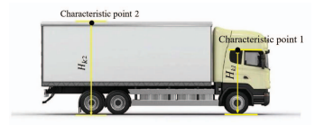

Fig 2.5.2 Selection of characteristic point

* Load value recognition model based on characteristic distance:

For a single suspension assembly, its static load characteristics can be obtained from the vehicle information database. The load of the vehicle has a specific conversion relationship with the load of the single suspension assembly, and the overall load data of the vehicle can be obtained according to the conversion relationship. The bearing characteristics of the front suspension (The front and rear suspensions refer to the front and rear suspension assemblies) and the rear suspension can be expressed as:



The characteristic distance values of the vehicle under different conditions are obtained, and the centroid position of the vehicle load and load is obtained from the calculation model. The relative average error of the load recognition is within 20%, which can meet the detection requirements of vehicle overload to a certain extent, and is meaningful for vehicle detection and intelligent transportation. And the load centroid position can be detected, the result guide the driver to load cargoes reasonably and drive safely. The experimental results show that the relative error of the identification of the vehicle load is still relatively large. The overall calculation model of the method needs to be corrected accordingly. A lot of experiments are needed for further verification. In addition, the establishment of the vehicle database is also very important.

**2.6 USING DP TOWARDS A SHORTEST PATH PROBLEM RELATED**

**APPLICATION**

The major bottleneck in the development of autonomous driving systems is perception. As one of the most essential tasks in perception, trafﬁc scene understanding consists of several computer vision tasks including lane and obstacle detection. The functions of lane detection systems are to recognize and localize lane markings on roads as well as provide drivers with a traversable area. Consequently, these systems are essential to ensure trafﬁc safety and enhance the driving experience in autonomous vehicles. However, lane detection is considered as a demanding task when the actual environment and road conditions such as occlusion, intersections, lights, and weather are considered. Several state-of-the-art approaches have achieved excellent performance in real applications. However, most of them are based on precise vanishing point (VP) estimation or a speciﬁc road model assumption. They do not perform well in challenging environments, such as crossings and turnings, where multiple VPs at different positions exist.

The left and right images captured by stereo cameras are denoted by Il and Ir respectively, the IPM image produced from Il is denoted by Ii, and the VP for Il is denoted by pvp. In the pre-processing module, a graph model G is constructed from Ii usingedgeinformation,asdepictedinFig.6. Then, several iterations are executed until the desired number of lanes are found in the path searching and model ﬁtting modules. At each separate iteration, we employ DP to ﬁnd the shortest path in G for each node in D. After that we select one path with the minimum cumulative cost. Its correctness will be checked through a parabolic model ﬁtting. Finally, the resulting models are projected to Il for visualization.

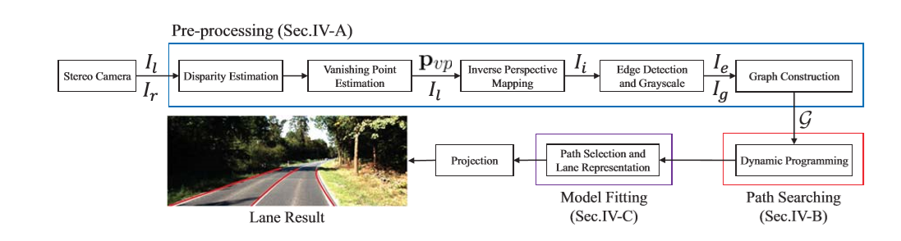

Fig 2.6.1 Flow diagram of lane detection

* Pre-processing

Vanishing Point Estimation :

VP is estimated using our previously published method where two dense accumulators are optimized to extract the desirable paths with the minimum cost. The extracted paths are then interpolated into a quadratic and quadruplicate polynomial, respectively. The VP can be computed using these two polynomials.

Edge Detection :

The Canny detector is used to ﬁnd the lane boundaries information, which includes a multi-stage process to detect a wide range of edges in images. It takes Ii as input, and returns a binary feature function fe(u,v), where u,v indicate the coordinates of a pixel and the pixel value is either 0 or 1. Speciﬁcally we deﬁne that the pixel value of an edge is 1.

Graph Construction :

Using the color, edge, and spatial information of pixels, the original image Ii can be easily modeled by the designed graph model G. For formulating lane detection as an SPP, the edge cost should be deﬁned appropriately. Since lanes are typically assumed to be painted in white or yellow in high contrast, we can intuitive utilize the edge and gray value to calculate the edge cost.

* Path Searching Based on DP for lane detection :

We apply the DP algorithm to a speciﬁc application: lane detection. In our implementation, we improve with an additional regularization. We can observe that noisy data are randomly distributed, but lane boundaries are connected continuously with strong spatial relationship. For this reason, we design λj2 to regulate the path generation in horizontal direction. On the other hand, the setting of λ may inﬂuence the structure of the resulting paths.

* Path Selection and Lane Representation :

To enhance the detection accuracy, a model ﬁtting module is developed. In this paper, we utilize a parabolic model f(v)=β2v2 + β1v + β0 to ﬁt the paths, which is sufﬁcient to represent lanes in the IPM images. We use P to indicate the path with the minimum cumulative cost, which is a V ×2 matrix.

The proposed algorithm is compared with another published lane detection method. In this method, lanes are detected based on VP estimation. All the experiments are evaluated with the KITTI dataset. With empirically setting the parameters we =0 .6, wg =0 .4, λ =2 , k =3 , tr =5, our method can obtain promising results. The IPM range covers a ground area of 30 m and 12 m in the Y and X directions, respectively. Lanes will be detected if they are located in this range.

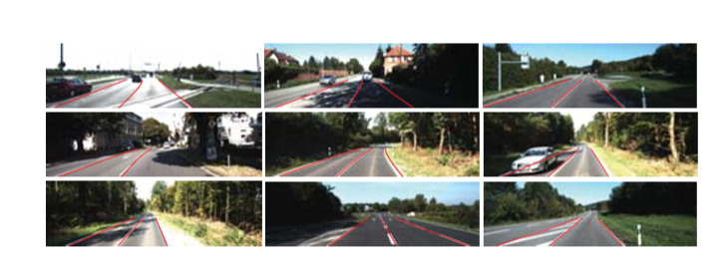

Fig 2.6.2 Detected lanes

The proposed algorithm presents a better precision, where 99% lanes are successfully detected in the ﬁrst three sequences, and the average precision in all sequences is 97.5%, while the precision of only reaches 94.5%.Paper proposed a directed graph model and a corresponding shortest path searching algorithm based on DP that can tackle a speciﬁc SPP effectively and also presented its application to lane detection. The results showed that the designed model and the proposed DP-based algorithm with great potential in solving visual recognition problems.

**2.7 PASSENGER MANAGEMENT SYSTEM BASED ON FACE**

**RECOGNITION FOR INTELLIGENT TRANSPORT VEHICLE**

In recent years, due to the increased interest and researches on the intelligent vehicle and the improvement of the performance of computing power and mobile communication technology, the intelligent service has been enabled in the vehicle using wireless communication network. Face identification is one of the important technologies for the intelligent transport vehicle applications such as authorized driver and passenger identification.

This describes the passenger management system based on the face recognition technology for intelligent transport vehicles. In the mass transport vehicles such as a public transport bus, a subway and a train, a lot of people get on and off at the same time, thus the speed of face detection is the most important issue for the development of intelligent vehicle system which can identify passengers. In this paper, the AdaBoost method utilizing Local Binary Pattern (LBP) histogram is employed for face detection system. And the cascade structure is also introduced in order to improve the detection speed. This paper describes a method of fast face detection and recognition system for identification of passengers of vehicles, who have been registered in advance to the passenger management system. In our study, the face detection performs in the moving vehicle whereas the face recognition does in remote passenger recognition server. The challenge is to build very fast and accurate face detection and recognition system.

Feature Extraction and AdaBoost Learning :

Local Binary Pattern (LBP) [6] was designed to represent the local-texture of the image. LBP operator is simple and of the low computational complexity, as well as invariant to monotonic gray level changes. The basic LBP method, as shown in the Fig., the center pixel in a 3x3 block is compared with around 8 pixels. And a comparison of eight binary values are calculated, the calculated LBP value between 0 and 255 is represented by the LBP pattern.

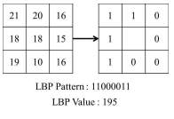

Fig 2.7.1 Example of basic LBP

AdaBoost algorithm proposed by Freund and Schapire is one of the boosting algorithms, and was successfully utilized for face detection where x is the input image in the detection window on the whole image, f is classified feature value, θ is threshold of feature, p is parity for direction, T is iteration number, αt is weight of weak classifier and βt is update factor of weak classifier.

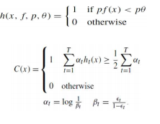

Cascade Structure for Improve of Detection Time:

To implement the real-time face detection, we use the cascade structure, as shown in the sub-images of input image are fed into the cascade structure. A series of weak classifiers are applied to every sub-image. if the sub-image has passed the previous weak classifier, this sub-image is input into the next weak classifier, otherwise rejected as a non-face.

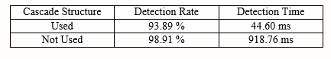

Fig 2.7.2 Cascading function

The passenger management system in our study consists of the device for the face detection and the remote server for the face recognition and passenger management. E Embedded device for the face detection was installed inside the intelligent transport vehicle. This device detects the face of students while they get on and off the bus. The detected face image is transmitted to the remote recognition server via wireless network. On the remote server which can recognize face images, if the transmitted face images from the bus are registered in advance in the student database, the server stores the time of getting on and off with identified student information. In this kind of school bus passenger management, the information all students to get on the bus are known beforehand. Thus, the server for face recognition and passenger management is able to provide parents with the boarding time and location of their children.

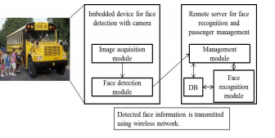

Fig 2.7.3 Passenger management system

**2.8 PASSENGER IN VEHICLE COUNTING METHOD OF HOV/HOT**

**SYSTEM**

In this paper, simple but refined image acquisition scheme and novel number of passenger counting algorithm are proposed. Especially, by incorporating deep neural network for face detection, integrating face detection results over plural frames and calculating confidence value of estimation result, useful and high accuracy has been realized. Automated number of passenger in vehicle counting system has been desired to realize for HOV (High Occupancy Vehicle) and HOT (High Occupancy Toll) use.

Affected by the heightened momentum for several environmental problems such as greenhouse effect gas and air pollution, there have been many efforts both in public and private sector. Among them because exhaust gas from vehicles occupies the large part of the cause of these issues, schemes of HOV and HOT have been administered in the United States and other countries. However, there exist drivers who violate this rule and pass through HOV lane with below the number of passengers. To exercise control over these violators, automated number of passengers in vehicle counting system has been required from the public sector for many years. For example, by installing a far-infrared sensor inside a vehicle for detection human as a heat source, the number of passengers in the vehicle can be counted directly.

Though this approach is straightforward from the viewpoint of technology, it is difficult to realize because all drivers who want to utilize HOV lane are compelled to purchase such kind of device. Moreover, once the number of passengers is counted by the onboard device, this information has to be submitted to road operator via some communication method such as wireless LAN and this requires additional radio access points. On the other hand, capturing vehicle image by roadside camera and counting the number of passengers by using image processing realize the automated counting system more easily. However, image acquisition system is required to capture good contrast images of passengers though they exist over the window of the vehicle. In this paper, a novel number of passengers counting method including system architecture, its image processing context and experiment result is described.

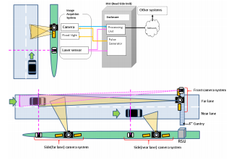

Fig 2.8.1 System configuration

The proposed system is composed of four main equipment: floodlights, cameras, a laser sensor, and processing unit (Fig. 1 – upper column). To count the number of passengers not only in the front row of sheets but also in rear rows, the camera is basically installed on the roadside and it captures side view of a vehicle. In case that system requirement is to count the number of passengers of a vehicle not passing through the lane adjacent to the roadside, this system configuration may occur the counting accuracy deterioration because of occlusion caused by a vehicle passing through the forefront lane. In such case, one camera will be installed at the gantry for capturing front sheet image and another camera will be installed at the roadside for shooting sheets except for front ones (Fig. 1 lower column).If this system is installed at the island of toll gate, the distance between camera and vehicle has no chance but to be short.

As a result, single image angle can’t cover both of tall and short vehicles simultaneously. To manage such a situation, two cameras are used, one of which is fixed at a higher position of camera supporting pole and another one is fixed at a lower position. After operating image processing on those two image streams, appropriate result of those will be adopted. The result selection criteria are such as detection score, laser sensor signal, confidence value (which is described in detail later) and so on. The counting result is stored in a hard disk drive and can be delivered to the external network node via the communication line. In the case of violator control, if the counting result is below the pre-defined threshold, this system may submit an alert signal to policeman immediately.

Floodlight :

Recently, dark tinted glasses are used in many vehicles for keeping privacy. To count the number of passengers through these glasses, the proposed system adopted large intensity floodlight. On the viewpoint of preventing from blinding driver’s eye in the front camera system, the wavelength of flood light is about 850nm. On the other hand, inside camera system, floodlight with the wavelength of 730nm is used because of low risk of blinding driver’s eye.

Camera :

Corresponding to the wavelength of floodlight, effective wavelength range of adopted camera covers from 300nm to 900nm. Image resolution is 1920x1080 and image angle is fixed so as to make face region size more than 50 pixels on the image. Because this system is required to operate with vehicle whose upper limit speed is 200km/h, a camera with 100 fps is chosen in proposed system to satisfy this requirement.

Laser Sensor :

This sensor is used to generate the trigger signal for floodlight illuminating, image capturing and image processing. The maximum reachable distance is 80m and its operation frequency is 100 Hz.

Processing Unit :

The processing unit is installed either in an outdoor enclosure or in a server room. On this unit both of “image dispatching process” and “passenger counting process” work. The details of these modules are described in later section. Hardware specification such as CPU with 6 cores of 3.4GHz, GPU with 8GB, and memory more than 16GB is desirable to realize practical throughput for HOV/HOV service.

The image processing function for the number of passengers counting consists of three components: face detection, detected face integration, and confidence value calculation.

Face detection from still image:

As the proposed system uses near-infrared floodlight and windows of vehicles contain some shielding materials, the contrast of the captured image is often very low. To improve this contrast deterioration, image preprocessing based on physical reflection model on the surface of an object is adopted. Because contrast deterioration depends on several factors such as weather, time, whether a window is open or not, three parameter sets of image preprocessing are prepared and these mean weak, strong, medium processing effect (Fig. 4).

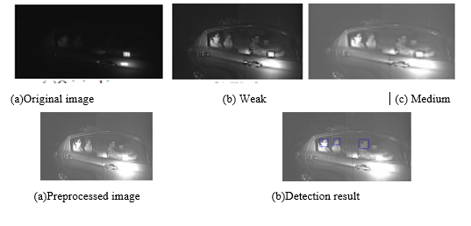

Fig 2.8.2 Sample result of face detection

Integration of face detection result:

While a vehicle exists in the camera shooting area, vehicle images are acquired by the camera system and therefore one vehicle running event consists of several images. One person appears and detected repeatedly in those images and so we have to classify all face detection results to which person they belong. This integration module is composed of three subroutines, the amount estimation of vehicle movement, face detection result classification, and error rejection.

To solve this problem, enhance frequency both of capturing image and image processing equivalent to increase the possibility to observe such passengers difficult to observe. On the other hand, frequency enhancement requires cost expensive camera and processing hardware, we would like to carefully judge whether this solution should be chosen or not.

**2.9 THE GENETIC ALGORITHM BASED ON ROUTE FINDING METHOD**

**FOR ALTERNATIVE PATHS**

We developed efficient genetic operators for path calculation. A major problem of the existing approach - similarities among the paths can be resolved using GA's. The performance of the suggested technique is evaluated and compared with the k-th shortest path for the virtual road network model by computer simulation. The results of computational experiments of the suggested method are found to be satisfactory in terms of the spread of alternatives. For efficient route guidance, several alternative paths should be provided in addition to the shortest one. It is often required to provide multiple paths to spread the traffic volume and to satisfy users' preferences. Algorithms for finding multiple paths from the given origin and destination - k-th shortest path - have been studied, and recently applied in finding realistic alternative paths.

Road Network :

A road network is represented by a graph G = (N, L), consisting of a set of nodes N = h, nz, .... , n,,,} and a set of links L = (11, 12, .... , In}. A link lk in L represents an ordered pair of nodes (i,j) Let o and d be two given nodes of (N, L). The chain from o to d in (N, L) is a sequence of nodes and links, of the form Io=n,, l,, np+l, &+I, ..., lq-1, q=d}, and is called a path. Moreover, when a path has the smallest link cost among all the paths, it is said to be the shortest path.

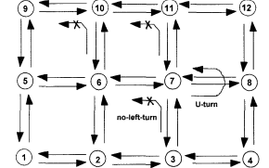

Fig 2.9.1 Representation road network

Alternative Paths :

Several paths may exist that have costs equal to or more than that of the shortest path. These are said to be alternative paths. There are some reasons that it is necessary to generate alternative paths in addition to the shortest one. First, from the viewpoint of traffic management center , providing multiple alternatives for drivers with similar origins and destinations would spread the traffic volume and thus increase the route efficiency. Second, drivers .may have various criteria not easily translated to a specific objective function. They can choose personally optimal route among the multiple paths For example, a driver may be satisfied with a route which is not the shortest path but has a quiet and beautiful scenery. Therefore, it is required to provide multiple alternative paths satisfying the purposes at costs not significantly greater than the cost of the shortest path early optimal path

For the purpose of improving the applicability to real routes, the above algorithm was modified to satisfy the U-turn, P-turn and no-left-turn constraints in this paper. As shown in Figure 2, it is highly probable that, except for some links, k paths similar to the shortest path would be selected in this method.

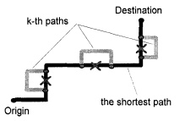

Fig 2.9.2 Kth shortest path

Validity Index for Alternative Paths :

In the dark arrows represent the shortest path and the dotted and grey arrows represent the alternative paths. As shown, alternative paths may or may not be overlapped with the shortest path. It means that diverse kinds of paths exist; fully different the present by the grey arrows), partially overlapped or mostly overlapped. The more overlapped with the shortest path, the less meaningful the alternative paths become in satisfying users' preferences or in spreading the traffic volume. The number of overlapped links or nodes has been used to evaluate the differences between the shortest path and the alternatives. However a new index is required to more effectively differentiate the validity of the alternatives.

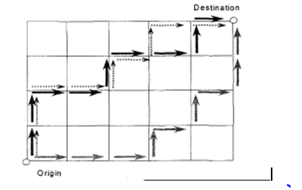

Fig 2.9.3 Alternative paths

If the purpose is to spread the traffic volume, crossed or neighboring alternatives may not be effective even though they are different from the shortest path according to the above criteria .As shown in Figure 4, the bigger the area surrounded by the shortest path and the alternatives, the more apart the paths and thus, the more dispersed the traffic.

Considering all these, we used the following three indices for validity

CNR : common nodes ratio number of common nodes / total number of common nodes for the shortest path links / total number of common links for the shortest path GA based route finding:

Genetic Algorithm Genetic Algorithm GA have received much attention as a robust stochastic searching technique for various optimization problems The alternative search technique using GA finds superior multiple paths in order of the time costs and spread of paths by suitable fitness function. That is, superior individuals for alternatives’ validity are maintained as paths evolve so that selecting k path individuals in the final generation would provide effective alternatives .The genetic algorithm used in searching for alternative paths consists of the following steps.

Procedure GA for Alternative paths

begin t=0

Initialize Path(t)

Evaluate Path(t)

while (not termination-condition)

do begin t=t+l

Select Path(t) from Path(t-1)

Crossover Path(t)

Mutation Path(t)

Remove unnecessary loop in Path(t)

Evaluate Path(t)

end

If more than one node exist, segments between the common nodes are randomly selected. A mutation operator randomly selects two points on a path. With these points as the origin and the destination, a new partial path is created and replaces the original segment. We presented a new approach to using genetic algorithms in finding multiple paper.

**2.10 PATH PLANNING ALGORITHM FOR VEHICLES BASED ON TIME**

**DEPENDENT OPTIMIZATION CRITERION**

A specialized genetic algorithm is proposed in this paper for path planning of vehicles based on time-dependent optimization criterion. A variable signal encoding scheme is adopted to represent the path and a particular fitness function is investigated for time-dependent shortest path planning. Domain heuristic knowledge based crossover, mutation and deletion operators are also specifically designed to fit the vehicle path planning problem. Furthermore, a new fuzzy logic control algorithm is integrated to self-adaptively adjust the probabilities of crossover and mutation in the proposed genetic algorithm. Simulation for both off-line and on-line path planning under five different environments are carried out, and the comparative studies with Dijkstra and A* algorithm are presented.

The vehicle path planning problem is often treated as how to find an optimum path between source and destination, which is typically required in ITS (Intelligent Traffic System). Generally, some optimization criteria (e.g., shortest length, minimum driving time or lowest transportation costs) must be satisfied, and other information should also be taken into consideration. Many optimization methods have been developed to solve this problem. These works can be classified into three groups according to their control strategies. The first uses graph theory, such as Dijkstra and Floyed algorithms. The second applies conventional artificial intelligence theory, such as A*, depth-first and breath-first search algorithms. The third employs intelligent techniques, especially genetic algorithms , which include related work of some of the authors of this paper.

Proposed genetic algorithm:

In order to illustrate the operation of the proposed genetic algorithm, a simple simulation map is shown here. It comprises a set of nodes such as A, B, C and a set of edges connecting the nodes. In the real electrical map, the nodes represent the crossover points of the roads and the edges represent the segments between crossover points. The data above the edges are the weights that indicate the velocity of each segment. The number below the edges is the actual length of each segment and its unit is kilometer. The relationship between the weight and the velocity can be obtained from this.

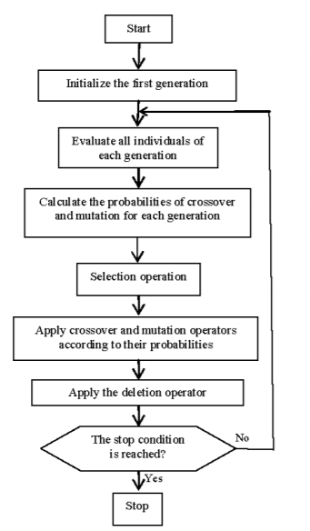

Fig 2.10.1 Flow chart

Encoding Scheme :

In this paper, the chromosomes (individuals) are encoded in a signal scheme [2] instead of binary or real number scheme as in conventional genetic algorithms. It consists of a sequence of intermediate nodes (genes) from source node to destination node.

Initialization of the First Generation:

The individuals of each generation (including the first generation) must have connectivity.

Fitness Function :

In this paper, the fitness function is defined by

F(xi ) = E jCj, j+l (j = 1,2, ..*, n)

Selection Operator :

The roulette wheel approach is adopted as the selection operator.

The Crossover Operator :

Find all common intermediate nodes between two parents' individuals. Select one node randomly as the crossover point. If the contents before or after the crossover point of two parents' individuals are the same, then cancel this crossover operation; otherwise, continue. Swap the contents after crossover point of two parents' individuals. Check the offspring and if loops emerge, delete it as suggested in .

Mutation Operator :

In order to increase the diversity of the population, a new mutation operation is specifically proposed for solving the path planning problem for vehicles. Select one intermediate node X randomly from the mutation individual as the mutation gene. Load the set N, which consists of all intermediate nodes connected with X. Choose one node Y randomly from the set N. If the node before node X is connected with node Y, then node Y is applied to replace node X in the new feasible path; otherwise cancel this mutation operation.

Deletion Operator :

In order to reduce the length and the time cost of each path, the deletion operator is proposed in this paper. The main idea is that if two non-conterminous nodes in a path can be connected directly, the intermediate nodes between them are redundant. Therefore, these intermediate nodes can be deleted.

Probabilities of Crossover and Mutation :

In order to avoid the phenomenon of premature convergence, an adaptive algorithm for controlling the probabilities of crossover and mutation is adopted in this paper. The changes of average fitness value and standard deviation between two continuous generations are selected as input variables, while the changes of crossover probability and mutation probability are the output variables.

**2.11 COMPARISON TABLE**

|  |  |  |  |  |  |
| --- | --- | --- | --- | --- | --- |
| PROPERTIES | **I** | **II** | **III** | **IV** | **V** |
| ACCURACY | HIGH | LOW | HIGH | HIGH | HIGH |
| COST | LOW | MODERATE | MODERATE | LOW | HIGH |
| EFFICIENCY | HIGH | HIGH | HIGH | MODERATE | HIGH |
| PRACTICABILITY | HIGH | HIGH | MODERATE | MODERATE | HIGH |
| TIME | LOW | MODERATE | MODERATE | HIGH | HIGH |

|  |  |  |  |  |  |
| --- | --- | --- | --- | --- | --- |
| PROPERTIES | **VI** | **VII** | **VIII** | **IX** | **X** |
| ACCURACY | HIGH | LOW | LOW | LOW | HIGH |
| COST | LOW | MODERATE | MODERATE | LOW | HIGH |
| EFFICIENCY | HIGH | HIGH | HIGH | MODERATE | HIGH |
| PRACTICABILITY | HIGH | HIGH | MODERATE | MODERATE | HIGH |
| TIME | LOW | MODERATE | MODERATE | HIGH | HIGH |

Table 2.11.1 Comparison table for detection & classification

**CHAPTER 3**

**SYSTEM ANALYSIS**

This chapter gives an overview about the existing system and the feasibility of the proposed system.

**3.1 EXISTING SYSTEM**

Optimal path prediction :

System designs a best path selection algorithm, which can solve the problem of path planning for intelligent driving vehicles in the case of restricted driving, traffic congestions and accidents. We tried to solve the problem under these emergency situations in path planning process for there’s no driver in intelligent driving vehicle. We designed a new method of the best path selection with length priority based on the prior knowledge applied reinforcement learning strategy, and improved the search direction setting of A* shortest path algorithm in the program. This best path planning algorithm can effectively help different types of intelligent driving vehicles to select the best path in the traffic network with limited height, width and weight, accidents and traffic jams. Through simulation experiments and practical test, it is proved that the proposed algorithm has good stability, high efficiency and practicability.

As an important part of intelligent transportation system, intelligent driving vehicles have outstanding research value. Vehicle drivers take action in the event of an emergency, but intelligently driven vehicles can only learn and try to avoid the danger of situation like traffic accident, jam and temporary restrictions, etc. in the process of continuous optimization of the path plan, therefore we propose this method to solve best path planning of intelligent driving vehicle. The path planning of intelligent vehicles is based on the driving tasks and real-time changing environment given by intelligent decision-making to provide the driving area and driving guidance process for intelligent vehicles, and this process is based on the controller interacting with the environment to get feedback and use intelligent determination technology to plan the path.

It is divided into global path planning and local path planning.Global path planning is a combination of optimization and feedback mechanisms using local information in the case of known map databases to determine feasible regions and optimal path. The vehicle may encounter various unpredictable situations during driving, so local path planning must be based on local environmental information, The best path for intelligent driving vehicle to travel is to optimize the path according to certain performance indicators, including the shortest path, the minimum total cost, and the shortest travel time. In this paper, the combination of priori reinforcement learning technology and searching-optimal shortest path algorithm to find best path for intelligent driving vehicle. This path optimization method can effectively help different types of intelligently driven vehicles to plan the best path in the traffic network under the conditions of limits including height, width and weight, accidents and congestions Path selection is an important aspect for intelligent driving vehicle. Here introduced OPABRL (Optimized Path Algorithm Based on Reinforcement Learning) algorithm for optimal path prediction.

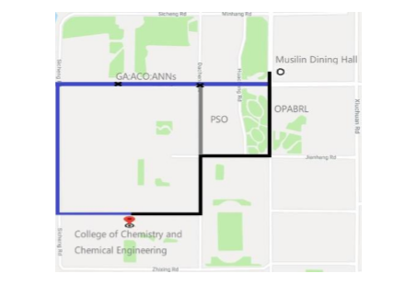

Fig 3.1.1 Optimal path

Passenger overload detection :

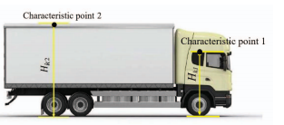

Fig 3.1.2 Selection of characteristics point

The vehicle suspension system can transmit forces and torques acting between the wheel and the frame, and cushion the impact force transmitted from the uneven road surface to the frame or the body to absorb the energy generated by the impact. Changes in vehicle load can cause deformation of the elastic element, the vehicle body will have a displacement in the vertical direction. Therefore, under static conditions, different vehicle loads correspond to a certain distance between the vehicle body characteristic points and the road surface. When there is a vehicle vibration excitation input, the vehicle suspension generates a vibration response, and the distance from the characteristic point on the vehicle body to the ground constantly changes.Load value recognition model based on characteristic distance:

The bearing characteristics of the front suspension (The front and rear suspensions refer to the front and rear suspension assemblies) and the rear suspension can be expressed as



The characteristic distance of the front and rear suspensions can be obtained through the visual roadbed, and the static deflection value is obtained. Through the front and rear suspension static deflection values, the load values M1 and M2 in the middle of the ideal condition on the two axles can be obtained. In the case of ignoring the position of the load centroid, the overall load can be obtained by the formula



Centroid calculation model for vehicle load:

The direction of the x-axis is the direction in which the vehicle is moving forward. The y-axis is the lateral direction of the vehicle and the z-axis is the vertical direction of the vehicle. A0B0C0D0 is the projection surface on the chassis plane under the no-load condition of the vehicle body. ABCD is the position plane of the body after the four suspensions are deformed. AA0, BB0, CC0, DD0 represent the left rear, right rear, left front, Right front suspension.

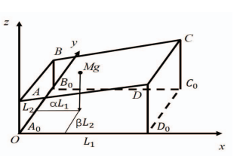

Fig 3.1.3 Vehicle coordinate system

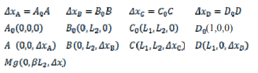

The medium and heavy-duty van is basically a mid mounted frame, and its frame can be simplified into a rigid body, so the ABCD is still coplanar after the deformation of each suspension. The geometric meaning of the deformation coordination relationship is that there is an intersection between the straight line AC and the straight line BD, and the ABCD is always in the same plane.

**3.2 PROPOSED SYSTEM**

This paper proposes and designs a best path selection algorithm, which can solve the problem of path planning for intelligent driving vehicles in the case of restricted driving, traffic congestions and accidents. We tried to solve the problem under these emergency situations in path planning process for there’s no driver in intelligent driving vehicle. We designed a new method of the best path selection with length priority based on the prior knowledge applied reinforcement learning strategy, and improved the search direction setting of A* shortest path algorithm in the program. This best path planning algorithm can effectively help different types of intelligent driving vehicles to select the best path in the traffic network with limited height, width and weight, accidents and traffic jams. Through simulation experiments and practical test, it is proved that the proposed algorithm has good stability, high efficiency and practicability**.**

This paper proposes and designs a best path selection algorithm, which can solve the problem of path planning for intelligent driving vehicles in the case of restricted driving, traffic congestions and accidents. We tried to solve the problem under these emergency situations in path planning process for there’s no driver in intelligent driving vehicle. We designed a new method of the best path selection with length priority based on the prior knowledge applied reinforcement learning strategy, and improved the search direction setting of A* shortest path algorithm in the program. This best path planning algorithm can effectively help different types of intelligent driving vehicles to select the best path in the traffic network with limited height, width and weight, accidents and traffic jams. Through simulation experiments and practical test, it is proved that the proposed algorithm has good stability, high efficiency and practicability**.**

Proposed system provide the optimal path and it also detection passenger overload taxies. Overload can be detected by using face recognizing method. In this method we consider the auto taxies .Setting the limit for passengers according to capacity of the vehicle .Number of passengers will be counted if it exceeds the limit then alert passed to traffic police. An IoT based passenger control system is introducing and a machine learning approach to find the optimal path.

Proposed system will predict the optimal path in cites by detecting the traffic congestions, road accidents and also give a warning if there is overload in taxies .Through this number ofaccidents can be avoided. Acquire image using camera.one camera at front and other at top .Face detecting whether the face is of the human or animal .Face recognition Recognizing and dividing the faces as normal , small , too small.

Count the number of passengers according to the face recognition.Analysis In analysis phase the passenger count is compared with limit in the system. Changes in vehicle load can cause deformation of the elastic element, the vehicle body will have a displacement in the vertical direction. Therefore, under static conditions, different vehicle loads correspond to a certain distance between the vehicle body characteristic points and the road surface. When there is a vehicle vibration excitation input, the vehicle suspension generates a vibration response, and the distance from the characteristic point on the vehicle body to the ground constantly changes. The side-mounted camera captures the change trajectory of this point, and by establishing an appropriate coordinate system, the vibration curve at a certain point on the vehicle body can be drawn. A reasonable filtering of the curve can obtain the characteristic distance value of the vehicle. Any point fixed on the vehicle that can move with the path of the vehicle body can be used as a characteristic point of the vehicle body. The distance from the characteristic point to the ground is called the characteristic distance. This paper proposes and designs a best path selection algorithm, which can solve the problem of path planning for intelligent driving vehicles in the case of restricted driving, traffic congestions and accidents. We tried to solve the problem under these emergency situations in path planning process for there’s no driver in intelligent driving vehicle. We designed a new method of the best path selection with length priority based on the prior knowledge applied reinforcement learning strategy, and improved the search direction setting of A* shortest path algorithm in the program. This best path planning algorithm can effectively help different types of intelligent driving vehicles to select the best path in the traffic network with limited height, width and weight, accidents and traffic jams.

**CHAPTER 4**

**DESIGN AND DEVELOPMENT**

This chapter focuses on the design and development of the system

**4.1 MODULE DESIGN**

This section depicts the architectural diagram of optimal path prediction and passenger overload prediction.

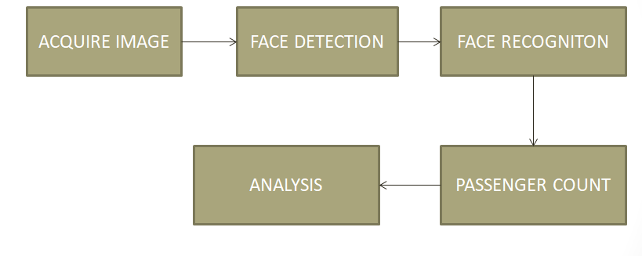

Fig 4.1.1 Block diagram of overload

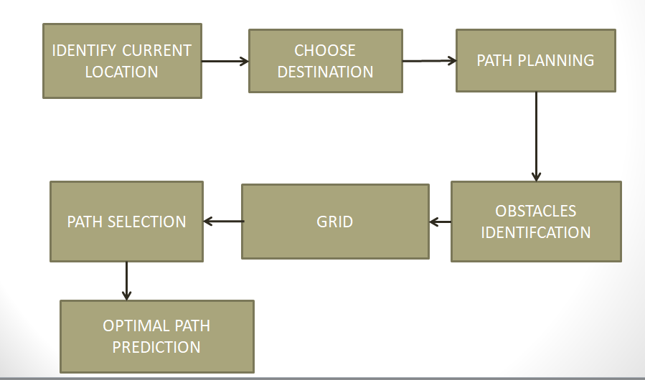

Fig 4.1.2 Block diagram of optimal path prediction

**4.2 MODULE DESCRIPTION**

The system consist of the following modules that are shown in fig 4.1.1 and fig 4.1.2

Acquire image: Acquire image using camera.one camera at front and other at top. Front cameras are cameras that are designed to placed in front of the vehicle facing forward. These cameras are designed so that you can avoid hitting parking blocks, curbs, and other potentially disastrous obstructions. Here it used for capturing the image of passengers.

Face detection: Detecting whether the face is of the human or animal. Face detection also detect the size of the images and divide the full image in to small sub images.

Face recognition: Recognizing and dividing the faces as normal , small , too small.Face recognition is a biometric software application capable of uniquely identifying or verifying a person by comparing and analyzing patterns based on the person's facial contours. Face recognition is mostly used for security purposes, though there is increasing interest in other areas of use.

Passenger count: Count the number of passengers according to the face recognition. Passenger count is carried out using the sub images that is formed as a result of face detection and after comparing with face detection.

Analysis : In analysis phase the passenger count is compared with limit in the system. Analyser is used for the analysis stage. An analyzer or analyzer is a person or device that analyses given data. It examines in detail the structure of the given data and tries to find patterns and relationships between parts of the data. An analyzer can be a piece of hardware or a computer program running on a computer.

Identify current location :GPS is connected so using that current location is identified. The [Global Positioning System (GPS)](http://www.civilsimplified.com/workshops/applications-of-gis) is a space-based satellite navigation system that provides location and time information in all weather conditions, anywhere on or near the Earth where there is an unobstructed line of sight to four or more [GPS satellites](http://www.civilsimplified.com/workshops/applications-of-gis). The system provides critical capabilities to military, civil and commercial users around the world. It is maintained by the United States government and is freely accessible to anyone with a GPS receiver. The [GPS](http://www.civilsimplified.com/workshops/applications-of-gis)is a satellite-based navigation system made up of a network of 24 satellites placed into orbit by the U.S.

Choose destination: The user or the passenger will give the destination through the option in the pop window .The user need to select their destination which is the user need to visit. The pop window will contain an app like structure to choose the name of destination and the corresponding number of the destination that is given in the list of places nearby.

Path planning: The system will detect the available path in the environment from start to destination. A fast path planning method by optimization of a path graph for both efficiency and accuracy is proposed. A conventional quad tree-based path planning approach is simple, robust, and efficient. However, it has two limitations. We propose a path graph optimization technique employing a compact mesh representation. A world space is triangulated into a base mesh and the base mesh is simplified to a compact mesh. The compact mesh representation is object-dependent; the positions of vertexes of the mesh are optimized according to the curvatures of the obstacles. For path planning here using a grid map.

Obstacle identification: Identify the obstacles in all path. Obstacle detection is the process of using sensors, data structures, and algorithms to detect objects or terrain types that impede motion. Obstacle detection is applicable to anything that moves, including robot manipulators and manned or unmanned vehicles for land, sea, air, and space; for brevity, these are all called vehicles here. Obstacle detection and hazard detection are synonymous terms, but are sometimes applied in different domains; for example, obstacle detection is usually applied to ground vehicle navigation, whereas hazard detection is often applied to aircraft or spacecraft in the process of landing, as in “landing hazard detection.” Obstacle detection is a system problem that encompasses sensors.

Grid: Using the identified obstacles the grid map is constructed. A map marked with a grid of regular squares, enabling a place to be precisely located by means of numbers or letters corresponding to each square. All the plant species were identified and their locations recorded on a grid map.

**4.3 USE CASE DIAGRAM**

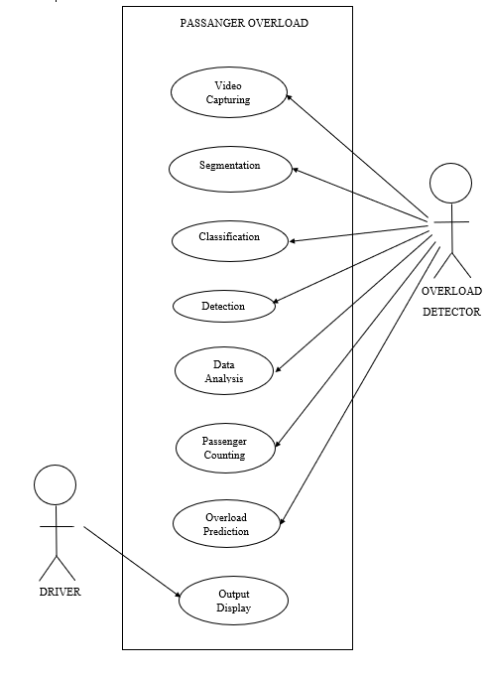

Fig 4.3.1 Use case diagram

Fig 4.31 shows the use case diagram of the proposed system in which the user can obtain the output display. Such that overload detector will be able to predict the overload.The processes involved here is such as video capturing,segmentation it is the process of partioning a digital image into multiple segments,Then it will classifies the images into person ,handbag and suitcase using deep learning technology,Next it’s carry out for detecting average count of passengers and it will be displayed on screen,Data analysis is done by obtaining raw data and converting them into information for the users.At last passenger count will be detected and it goes for overload prediction ,if the passenger count exceed from the limit alarm work by giving a beep sound to the respective driver.

**4.4 ENTITY RELATIONSHIP DIAGRAM**

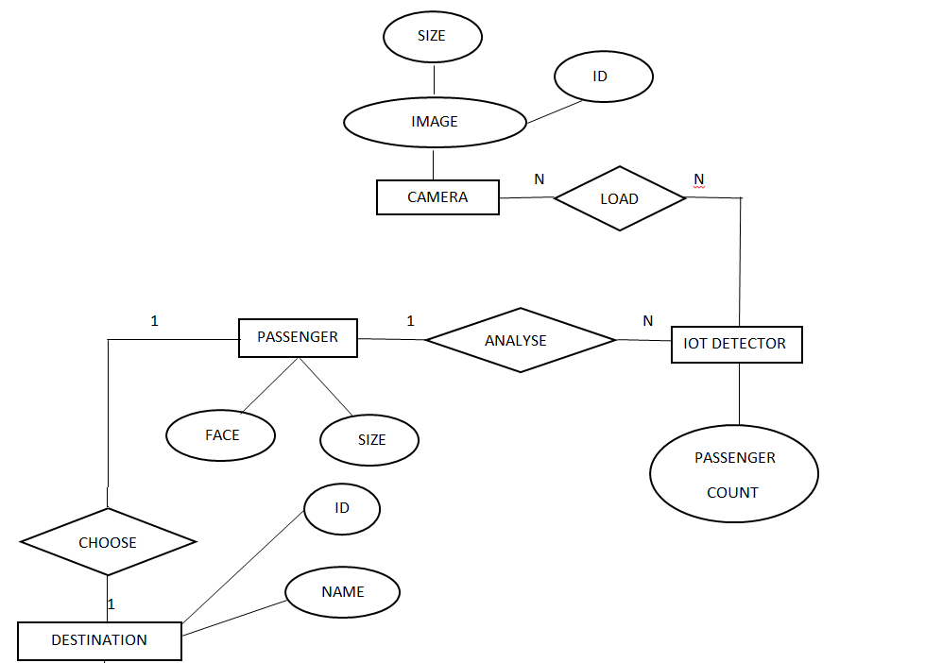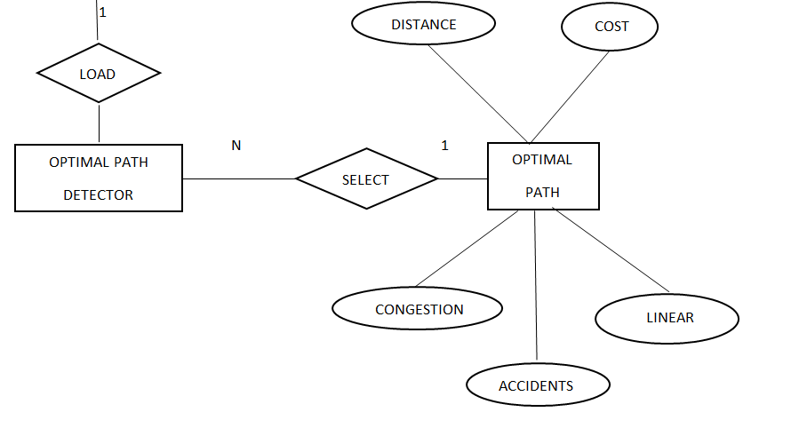

Fig 4.4.1 Entity relationship diagram

Fig shows the entity relationship diagram for the proposed system. It consist of 3 entities Passenger, IOT detector, Destination, Camera ,Optimal path detector ,Optimal path. Camera collects the image with attributes like id and size and loaded to IOT Detector for finding passenger count. IOT Detector will analyze the Passengers by using their size (weight) and image .Passengers can choose the destination with help passenger ID and name. The path can be obtained by using optimal path detector.

**CHAPTER 5**

**TECHNOLOGY DESCRIPTION**

**5.1 SOFTWARE SPECIFICATION**

* Windows 10

Windows 10 is a computer operating system by Microsoft as part of it’s windows family of operating systems. It was known as threshold when it was being developed and announced at a press event on 30 September 2014. It came out for PCs on July 29, 2015. Beginning on that day, windows 10 was available as a free upgrade for users running windows 7 and windows 8.1 for one year.

Windows 10 is designed to provide a common, “Universal“ user interface between desktop, laptop and all in one PCs, tablet computers, smartphones and embedded systems such as Xbox game console. Many of it’s features have been added based up on feedback from users, who are testing the software before it is released. It is being designed under the software as a service principle, in which the software will receive updates on a frequent basis throughout it’s life span.

* Python 3.7

Python is an interpreted high-level programming language for general-purpose programming. Created by Guido van Rossun and first released in 1991, python has a design philosophy that emphasizes code readability, notably using significant white space. It provides constructs that enable clear programming on both small and large scales. In July 2018, Van Rossun stepped down as the leader in the language community after 30 years.

* Google Colab

Google Colab is a free cloud service.it improves Python programming language coding skills. Develop deep learning applications using popular libraries such as Keras, TensorFlow, PyTorch, and OpenCV in the cloud.

Google Colab Colaboratory is always an free Jupyter notebook environment that requires no setup and runs entirely and execute code, save and share your analyses, and access powerful computing resources, all for free from your brower. Google Colab comes with collaboration backed in the product. In fact, it is a Jupyter notebook that leverages Google Docs collaboration features.

* Anacoda 3

Anaconda is a free and open-source distribution of the Python and R programming languages for scientific computing (data science, machine learning applications, large-scale data processing, predictive analytics, etc.), that aims to simplify package management and deployment.Spyder, the Scientific Python Development Environment, is a free integrated development environment (IDE) that is included with Anaconda. It includes editing, interactive testing, debugging, and introspection features. Spyder is also pre-installed in Anaconda Navigator, which is included in Anaconda.

* YOLO

YOLO: Real-Time Object Detection. You only look once (YOLO) is a state-of-the-art, real-time object detection system.Detection is a more complex problem than classification, which can also recognize objects but doesn’t tell you exactly where the object is located in the image and it won’t work for images that contain more than one object. YOLO is a clever neural network for doing object detection in real-time. YOLO is a convolutional neural network based model that detects objects in real time using the "You Only Look Once" framework.It is always based on which in dark flow and can detect over 9000 different objects with 70% accuracy.

* Open CV

OpenCV ( Open source computer vision) is a library of programming functions mainly aimed at real-time computer vision. Originally developed by Intel, it was later supported by Willow Garage then which was later acquired by Intel The library is cross-platform and free for use under the open-source BSD license. OpenCV is an open source computer vision and machine learning software library. OpenCV was built to provide a common infrastructure for computer vision applications and to accelerate the use of machine perception in the commercial products.

**5.2 HARDWARE SPECIFICATION**

* Camera

A camera is an [optical](https://en.wikipedia.org/wiki/Optics) instrument to capture [still images](https://en.wikipedia.org/wiki/Still_image) or to record [moving images](https://en.wikipedia.org/wiki/Moving_image), which are stored in a physical medium such as in a [digital system](https://en.wikipedia.org/wiki/Digital_storage) or on [photographic film](https://en.wikipedia.org/wiki/Photographic_film). A camera consists of a [lens](https://en.wikipedia.org/wiki/Camera_lens) which focuses light from the scene, and a [camera body](https://en.wikipedia.org/wiki/Camera_body) which holds the image capture mechanism. The still image camera is the main instrument in the art of [photography](https://en.wikipedia.org/wiki/Photography) and captured images may be reproduced later as a part of the process of photography, [digital imaging](https://en.wikipedia.org/wiki/Digital_imaging), [photographic printing](https://en.wikipedia.org/wiki/Photographic_printing). The similar artistic fields in the moving image camera in the specified domain are [film](https://en.wikipedia.org/wiki/Film), [videography](https://en.wikipedia.org/wiki/Videography), and [cinematography](https://en.wikipedia.org/wiki/Cinematography). The word camera comes from [camera obscura](https://en.wikipedia.org/wiki/Camera_obscura), which means "dark chamber" and is the Latin name of the original device for projecting an image of external reality onto a flat surface. The modern photographic camera evolved from the camera obscura. The functioning of the camera is very similar to the functioning of the human eye.

* Arduino Uno

The Arduino Uno is an [open-source](https://en.wikipedia.org/wiki/Open-source) [microcontroller board](https://en.wikipedia.org/wiki/Microcontroller_board) based on the [Microchip](https://en.wikipedia.org/wiki/Microchip_Technology) [ATmega328P](https://en.wikipedia.org/wiki/ATmega328P) microcontroller and developed by [Arduino.cc](https://en.wikipedia.org/wiki/Arduino). The board is equipped with sets of digital and analog [input/output](https://en.wikipedia.org/wiki/Input/output) (I/O) pins that may be interfaced to various [expansion boards](https://en.wikipedia.org/wiki/Expansion_board) (shields) and other circuits. The board has 14 digital I/O pins (six capable of [PWM](https://en.wikipedia.org/wiki/Pulse-width_modulation) output), six analog I/O pins, and is programmable with the [Arduino IDE](https://en.wikipedia.org/wiki/Arduino#Software) (Integrated Development Environment), via a type B [USB cable](https://en.wikipedia.org/wiki/USB_cable).[[4]](https://en.wikipedia.org/wiki/Arduino_Uno#cite_note-priceton-4) It can be powered by the USB cable or by an external [9-volt battery](https://en.wikipedia.org/wiki/9-volt_battery), though it accepts voltages between 7 and 20 volts. It is also similar to the [Arduino Nano](https://en.wikipedia.org/wiki/Arduino_Nano) and Leonardo.[[5]](https://en.wikipedia.org/wiki/Arduino_Uno#cite_note-5)[[6]](https://en.wikipedia.org/wiki/Arduino_Uno#cite_note-6) The hardware reference design is distributed under a [Creative Commons](https://en.wikipedia.org/wiki/Creative_Commons) Attribution Share-Alike 2.5 license and is available on the Arduino website. Layout and production files for some versions of the hardware are also available. The word "[uno](https://en.wiktionary.org/wiki/uno" \o "wikt:uno)" means "one" in [Italian](https://en.wikipedia.org/wiki/Italian_language) and was chosen to mark the initial release of [Arduino Software](https://en.wikipedia.org/wiki/Arduino_Software). The Uno board is the first in a series of USB-based Arduino boards; it and version 1.0 of the Arduino [IDE](https://en.wikipedia.org/wiki/Integrated_development_environment) were the reference versions of Arduino, which have now evolved to newer releases. The ATmega328 on the board comes pre programmed with a [boot loader](https://en.wikipedia.org/wiki/Bootloader) that allows uploading new code to it without the use of an external hardware programmer.

* Magneto resistance sensor

Magneto resistance is the tendency of a material (preferably ferromagnetic) to change the value of its [electrical resistance](https://en.wikipedia.org/wiki/Electrical_resistance) in an externally-applied [magnetic field](https://en.wikipedia.org/wiki/Magnetic_field). There are a variety of effects that can be called magneto resistance. Other effects occur in magnetic metals, such as negative magneto resistance in ferro magnets or anisotropic magneto resistance (AMR). Finally, in multicomponent or multilayer systems (e.g. magnetic tunnel junctions), [giant magneto resistance](https://en.wikipedia.org/wiki/Giant_magnetoresistance) (GMR), [tunnel magneto resistance](https://en.wikipedia.org/wiki/Tunnel_magnetoresistance) (TMR), [colossal magneto resistance](https://en.wikipedia.org/wiki/Colossal_magnetoresistance) (CMR),and [extraordinary magneto resistance](https://en.wikipedia.org/wiki/Extraordinary_magnetoresistance) (EMR) can be observed.

**CHAPTER 6**

**CONCLUSION**

System will predict the optimal path in cites by detecting the traffic congestions, road accidents and also give a warning if there is overload in taxies .Through this number of accidents can be avoided. In the current context of smart city, specifically in the industrial and market zones, the traffic scenario is very congested at the peak time of business hours. Due to increasing growth of population and vehicles in smart and metropolitan cities people face a lot of problem at the major traffic points of the business towns. The “IoT based passenger control and traffic analysis in smart cities” predict the spatial information available in real time environment. The data collected by mobile IoT devices are uploaded as input to the system. Then Machine learning concepts and techniques are applied to make predictions. This includes optimal travel path and number of person pickup by taxis. The system will analyze the number of passengers using face detection algorithm and compare with the overloading conditions to avoid accidents. Using this we can implement a system for optimal path planning and we can detect the overload in taxies.

**REFERENCES**

[1] J. Zhao and G. Yan, "Passenger Flow Monitoring of Elevator Video Based on Computer Vision," 2019 Chinese Control And Decision Conference (CCDC), Nanchang, China, 2019, pp. 2089-2094, doi: 10.1109/CCDC.2019.8833248.

[2]

[3] Liu junli. “Statistical analysis of bridge collapse cases caused by overloading between 2007 and 2015,” Chinese Journal of Highway,2017(4):79-82.

[4] Zhao Yin. “The application of vehicle type weighing system in highway” [J]. Transportation Informatization,2014,15(9): 74-75+ 82. [3] Bai lei, “Design and experimental analysis of dynamic weighing sensor based on fiber grating,” Shanxi industrial technology.2014(3):288-289.

[5] Fen, Lin., Chao, Huang., and Wei Wang., “Serial RLS-based Dualparameter Combined Identification for Vehicles,” Journal of South China University of Technology, 2012, 40(12):105-110.

[6] Xin, Dai., “Design and Development of the Multi- information Fusion of Weigh-in-motion System,” Beijing Jiaotong University, 2014.

[7] Daojiong, Chen., Shangzhong, Gao., Zhifeng, Gao., and Qun, Wei., “Research of Truck-Mounted Dynamic Weighing System,” Automobile Technology, 2008(6):8-12.